Intercollegiate Athletic Database Tables
The Intercollegiate Athletic database is used in assignments 1 and 2. This document describes the tables and relationships.

Table Description and Usage
The Intercollegiate Athletic database supports the scheduling and operation of events. Customers initiate event requests with the Intercollegiate Athletic Department. Events are sometimes scheduled several months in advance. The facility and date held are recorded on an event request. If an event request is denied, no additional action is taken. If an event request is approved, one or more event plans are made. Typically, event plans are made for the setup, operation, and clean up of an event. An employee is assigned to manage an event plan before the plan is executed. Initially, there may not be an assigned employee. An event plan consists of one or more event plan lines. In an event plan line, the resource, location, time, and number of resources (EventPlanLine.Number) are recorded.
The EventRequest table is the hub of the database. An event request represents an event scheduled at a facility. For example, a basketball game may be scheduled at the gymnasium. Holding an event involves plans for allocation of resources including personnel and equipment. The EventPlan table contains plans for the setup, operation, and cleanup of an event. The EventPlanLine table contains the individual resources required in an event plan. Resources are assigned to specific locations of a facility. For example, guards may be required at the gates of the football stadium.

Population of Sample Tables
Sample rows are shown for each table in the Intercollegiate Athletic Database. You will populate the tables in Assignment 1 and query the tables in Assignment 2 using either Oracle or MySQL. Note that some columns are formatted (such as rate and estcost), but that you should consider these column values as numeric. Columns with missing values mean that the CREATE TABLE statement should not have NOT NULL constraints. For example, BudNo column in the EventRequest table has missing values so the BudNo column should not have NOT NULL constraint.
Customer
custno | custname | address | Internal | contact | phone | city | state | zip
C100 | Football | Box 352200 | Y | Mary Manager | 6857100 | Boulder | CO | 80309
C101 | Men's Basketball | Box 352400 | Y | Sally Supervisor | 5431700 | Boulder | CO | 80309
C103 | Baseball | Box 352020 | Y | Bill Baseball | 5431234 | Boulder | CO | 80309
C104 | Women's Softball | Box 351200 | Y | Sue Softball | 5434321 | Boulder | CO | 80309
C105 | High School Football | 123 AnyStreet | N | Coach Bob | 4441234 | Louisville | CO | 80027
Employee
empno | empname | department | email | phone
E100 | Chuck Coordinator | Administration | chuck@colorado.edu | 3-1111
E101 | Mary Manager | Football | mary@colorado.edu | 5-1111
E102 | Sally Supervisor | Planning | sally@colorado.edu | 3-2222
E103 | Alan Administrator | Administration | alan@colorado.edu | 3-3333
Facility
facno | facname
F100 | Football stadium
F101 | Basketball arena
F102 | Baseball field
F103 | Recreation room
Location
locno | facno | locname
L100 | F100 | Locker room
L101 | F100 | Plaza
L102 | F100 | Vehicle gate
L103 | F101 | Locker room
L104 | F100 | Ticket Booth
L105 | F101 | Gate
L106 | F100 | Pedestrian gate
ResourceTbl
resno | resname | rate
R100 | attendant | $10.00
R101 | police | $15.00
R102 | usher | $10.00
R103 | nurse | $20.00
R104 | janitor | $15.00
R105 | food service | $10.00
EventRequest
eventno | dateheld | datereq | facno | custno | dateauth | status | estcost | estaudience | budno
E100 | 25-Oct-2013 | 06-Jun-2013 | F100 | C100 | 08-Jun-2013 | Approved | $5,000.00 | 80000 | B1000
E101 | 26-Oct-2013 | 28-Jul-2013 | F100 | C100 |  | Pending | $5,000.00 | 80000 | B1000
E102 | 14-Sep-2013 | 28-Jul-2013 | F100 | C100 | 31-Jul-2013 | Approved | $5,000.00 | 80000 | B1000
E103 | 21-Sep-2013 | 28-Jul-2013 | F100 | C100 | 01-Aug-2013 | Approved | $5,000.00 | 80000 | B1000
E104 | 03-Dec-2013 | 28-Jul-2013 | F101 | C101 | 31-Jul-2013 | Approved | $2,000.00 | 12000 | B1000
E105 | 05-Dec-2013 | 28-Jul-2013 | F101 | C101 | 01-Aug-2013 | Approved | $2,000.00 | 10000 | B1000
E106 | 12-Dec-2013 | 28-Jul-2013 | F101 | C101 | 31-Jul-2013 | Approved | $2,000.00 | 10000 | B1000
E107 | 23-Nov-2013 | 28-Jul-2013 | F100 | C105 | 31-Jul-2013 | Denied | $10,000.00 | 5000
EventPlan
planno | eventno | workdate | notes | activity | empno
P100 | E100 | 25-Oct-2013 | Standard operation | Operation | E102
P101 | E104 | 03-Dec-2013 | Watch for gate crashers | Operation | E100
P102 | E105 | 05-Dec-2013 | Standard operation | Operation | E102
P103 | E106 | 12-Dec-2013 | Watch for seat switching | Operation
P104 | E101 | 26-Oct-2013 | Standard cleanup | Cleanup | E101
P105 | E100 | 25-Oct-2013 | Light cleanup | Cleanup | E101
P199 | E102 | 10-Dec-2013 | Standard operation | Operation | E101
P299 | E101 | 26-Oct-2013 |  | Operation | E101
P349 | E106 | 12-Dec-2013 |  | Cleanup | E101
P85 | E100 | 25-Oct-2013 | Standard operation | Setup | E102
P95 | E101 | 26-Oct-2013 | Extra security | Setup | E102
EventPlanLine
PlanNo | LineNo | TimeStart | TimeEnd | NumberFld | LocNo | ResNo
P100 | 1 | 25-Oct-2013 8:00 | 25-Oct-2013 17:00 | 2 | L100 | R100
P100 | 2 | 25-Oct-2013 12:00 | 25-Oct-2013 17:00 | 2 | L101 | R101
P100 | 3 | 25-Oct-2013 7:00 | 25-Oct-2013 16:30 | 1 | L102 | R102
P100 | 4 | 25-Oct-2013 18:00 | 12-Dec-2013 22:00 | 2 | L100 | R102
P101 | 1 | 3-Dec-2013 18:00 | 3-Dec-2013 20:00 | 2 | L103 | R100
P101 | 2 | 3-Dec-2013 18:30 | 3-Dec-2013 19:00 | 4 | L105 | R100
P101 | 3 | 3-Dec-2013 19:00 | 3-Dec-2013 20:00 | 2 | L103 | R103
P102 | 1 | 5-Dec-2013 18:00 | 5-Dec-2013 19:00 | 2 | L103 | R100
P102 | 2 | 5-Dec-2013 18:00 | 5-Dec-2013 21:00 | 4 | L105 | R100
P102 | 3 | 5-Dec-2013 19:00 | 5-Dec-2013 22:00 | 2 | L103 | R103
P103 | 1 | 12-Dec-2013 18:00 | 12-Dec-2013 21:00 | 2 | L103 | R100
P103 | 2 | 12-Dec-2013 18:00 | 12-Dec-2013 21:00 | 4 | L105 | R100
P103 | 3 | 12-Dec-2013 19:00 | 12-Dec-2013 22:00 | 2 | L103 | R103
P104 | 1 | 26-Oct-2013 18:00 | 26-Oct-2013 22:00 | 4 | L101 | R104
P104 | 2 | 26-Oct-2013 18:00 | 26-Oct-2013 22:00 | 4 | L100 | R104
P105 | 1 | 25-Oct-2013 18:00 | 25-Oct-2013 22:00 | 4 | L101 | R104
P105 | 2 | 25-Oct-2013 18:00 | 25-Oct-2013 22:00 | 4 | L100 | R104
P199 | 1 | 10-Dec-2013 8:00 | 10-Dec-2013 12:00 | 1 | L100 | R100
P349 | 1 | 12-Dec-2013 12:00 | 12-Dec-2013 15:30 | 1 | L103 | R100
P85 | 1 | 25-Oct-2013 9:00 | 25-Oct-2013 17:00 | 5 | L100 | R100
P85 | 2 | 25-Oct-2013 8:00 | 25-Oct-2013 17:00 | 2 | L102 | R101
P85 | 3 | 25-Oct-2013 10:00 | 25-Oct-2013 15:00 | 3 | L104 | R100
P95 | 1 | 26-Oct-2013 8:00 | 26-Oct-2013 17:00 | 4 | L100 | R100
P95 | 2 | 26-Oct-2013 9:00 | 26-Oct-2013 17:00 | 4 | L102 | R101
P95 | 3 | 26-Oct-2013 10:00 | 26-Oct-2013 15:00 | 4 | L106 | R100
P95 | 4 | 26-Oct-2013 13:00 | 26-Oct-2013 17:00 | 2 | L100 | R103
P95 | 5 | 26-Oct-2013 13:00 | 26-Oct-2013 17:00 | 2 | L101 | R104

Primary and Foreign Keys
The primary and foreign keys are depicted in Figure 1. An event request is related to many (one or more) event plans but only one customer. An event plan contains many event plan lines but only one supervising employee. An event plan line references a resource and location. A facility has many locations, but a location is specific to a facility.
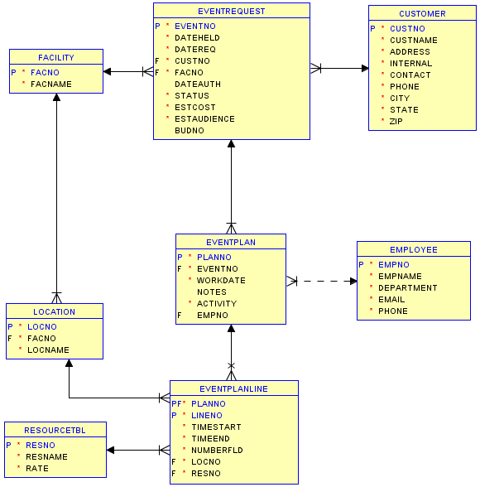
Figure 1: Oracle Relational Database Diagram for the Intercollegiate Athletic Database
All foreign key columns are required except for EventPlan.EmpNo. When a column is required, the user must enter a valid value according to the specified integrity rules (including referential integrity). For example when entering a new row in the EventRequest table, the user must know the customer number.

